SOFT COMPUTING
ASSIGNMENT -8
Perumalla Dharan
AP21110010201

import numpy as np
import tensorflow as tf
from tensorflow.keras import layers, models
from tensorflow.keras.datasets import mnist
from tensorflow.keras.utils import to_categorical

(training_set_images, training_set_labels), (testing_set_images, testing_set_labels) = mnist.load_data()

training_set_images = training_set_images.astype('float32') / 255.0
testing_set_images = testing_set_images.astype('float32') / 255.0

training_set_images = np.reshape(training_set_images, (training_set_images.shape[0], 28 * 28))
testing_set_images = np.reshape(testing_set_images, (testing_set_images.shape[0], 28 * 28))

training_set_labels = to_categorical(training_set_labels, num_classes=10)
testing_set_labels = to_categorical(testing_set_labels, num_classes=10)

model = models.Sequential()
model.add(layers.Input(shape=(28 * 28,)))
model.add(layers.Dense(512, activation='relu'))
model.add(layers.Dense(256, activation='relu'))
model.add(layers.Dense(10, activation='softmax'))

model.compile(optimizer='adam', loss='categorical_crossentropy', metrics=['accuracy'])

epochs = 10
for epoch in range(epochs):
print(f"Running Epoch {epoch + 1} out of {epochs}")
history = model.fit(training_set_images, training_set_labels, epochs=1, batch_size=32, validation_split=0.2, verbose=0)
current_accuracy = history.history['accuracy'][0]
print(f"Current Accuracy Here: {current_accuracy * 100:.2f}%")

testing_loss, testing_accuracy = model.evaluate(testing_set_images, testing_set_labels)

print(f"The Accuracy of this BPNN Model Is : {testing_accuracy * 100:.2f}%")

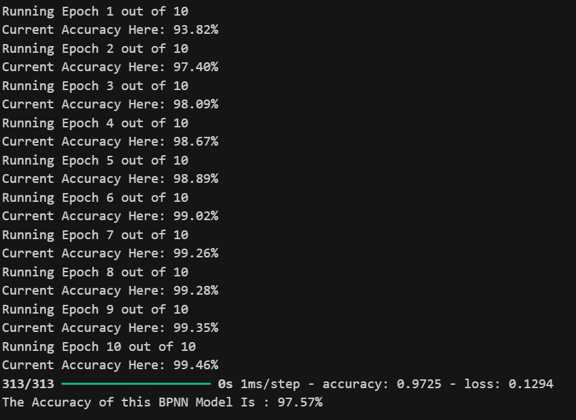

import numpy as np
from sklearn.datasets import fetch_openml
from sklearn.model_selection import train_test_split
from sklearn.preprocessing import StandardScaler
from sklearn.neural_network import MLPClassifier

def load_data():
mnist = fetch_openml('mnist_784')
X, y = mnist['data'], mnist['target'].astype(int)
return train_test_split(X, y, test_size=0.2, random_state=42)

def preprocess_data(X_train, X_test):
scaler = StandardScaler()
X_train_scaled = scaler.fit_transform(X_train)
X_test_scaled = scaler.transform(X_test)
return X_train_scaled, X_test_scaled

def train_mlp(X_train, y_train, epochs=10):
mlp = MLPClassifier(hidden_layer_sizes=(128, 64), activation='relu', max_iter=100, warm_start=True, random_state=42)

for epoch in range(epochs):
mlp.fit(X_train, y_train)
yield epoch + 1, mlp

def calculate_accuracy(model, X, y):
predictions = model.predict(X)
return np.mean(predictions == y) * 100

X_train, X_test, y_train, y_test = load_data()
X_train_scaled, X_test_scaled = preprocess_data(X_train, X_test)

epochs = 10
for epoch, model in train_mlp(X_train_scaled, y_train, epochs):
current_accuracy = calculate_accuracy(model, X_train_scaled, y_train)
print(f"Running Epoch {epoch} out of {epochs}")
print(f"Accuracy in this Epoch Is : {current_accuracy:.2f}%")

final_test_accuracy = calculate_accuracy(model, X_test_scaled, y_test)

print(f"The Accuracy of this MLP Model Is : {final_test_accuracy:.2f}%\n")

